Student worksheet

2.1 Darwin and Wallace were co-conspirators

Pages 40–43

Evolutionary theory

1 What is relative dating?

|  |
| --- |
|  |
|  |

2 Match the scientists with the correct contribution they gave to evolutionary theory:

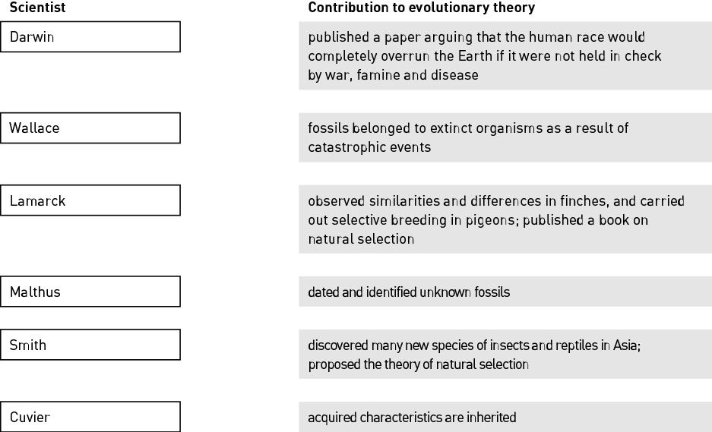

3 Using an example (other than giraffes), outline Lamarck’s theory of evolution.

|  |
| --- |
|  |
|  |
|  |
|  |

4 Describe the experiment Wiseman used to disproved Lamarck’s theory.

|  |
| --- |
|  |
|  |
|  |
|  |

5 Explain what is meant by ‘reproducible experimental evidence’. Include an example in your explanation.

|  |
| --- |
|  |
|  |
|  |
|  |
|  |

6 Give an example of an organism that has been selectively bred by humans.

|  |
| --- |
|  |
|  |

7 Explain how selective breeding leads to domestication of a species.

|  |
| --- |
|  |
|  |
|  |

Extend your understanding

The two types of tortoises Darwin observed on the Galapagos Islands have either large, round shells (domed shells) or small, curved shells (saddleback shells).

8 In the following table, suggest a possible food each tortoise would eat and explain the advantage of having this shell type in terms of obtaining food.

|  |  |  |
| --- | --- | --- |
|  | Domed-shell tortoise | Saddleback-shell tortoise |
| Photo of tortoise showing shell shape |  |  |
| Possible food |  |  |
| Advantage of shell shape |  |  |

9 Suggest a possible conclusion that Lamarck may have made about saddleback-shell tortoises based on his theory of acquired evolution.

|  |
| --- |
|  |
|  |
|  |
|  |

Student worksheet

2.2 Natural selection is the mechanism of evolution

Pages 44–45

Natural selection

1 Write your own definition for the term gene pool with regards to genes and alleles.

|  |
| --- |
|  |
|  |
|  |

2 The following image shows a population of red-beetles on a tree trunk. Red-beetles have either red, orange or brown wing colour.

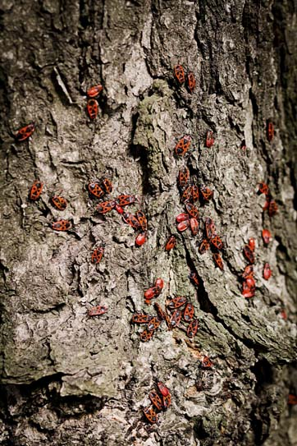

a Decide if each of the following descriptions is an observation or an inference.

i *‘Individual red-beetles that are most suited to their environment will survive.’*

|  |
| --- |
|  |

ii *‘There are red-beetle individuals with different wing colours.’*

|  |
| --- |
|  |

iii *‘Red-beetle parents will pass on their wing colour to their offspring.’*

|  |
| --- |
|  |

b Although the red-beetles within this population all have the same gene for wing colour, there is variation in wing colour between the red-beetles. Explain where this variation comes from.

|  |
| --- |
|  |
|  |
|  |
|  |

c Give ONE example of a possible selection pressure acting on this population of red-beetles.

|  |
| --- |
|  |

d A new predatory species of bird is now eating this species of red-beetles, as seen in the data in the following table.

changes in frequency of different coloured red-beetles over 12 months after the introduction of predatory birds

|  |  |  |  |
| --- | --- | --- | --- |
| Time (months) | Red-winged red-beetle | Orange-winged  red-beetle | Brown-winged  red-beetle |
| 0 | 28 | 13 | 6 |
| 3 | 16 | 14 | 8 |
| 6 | 14 | 12 | 14 |
| 9 | 8 | 10 | 19 |
| 12 | 4 | 11 | 23 |

In the space below, draw a line graph showing changes in the frequency of red-, orange-, and brown-winged red-beetles over 12 months.

|  |
| --- |
|  |

e Which phenotype is being selected against?

|  |
| --- |
|  |

f Suggest why there was an increase in the number of brown-winged red-beetles within this population.

|  |
| --- |
|  |
|  |

g In your own words, outline how the process of natural selection has altered the allele frequency for the wing-colour gene within the population of red-beetles over time.

|  |
| --- |
|  |
|  |
|  |
|  |
|  |
|  |

Extend your understanding

3 Apply your understanding of natural selection to discuss how the use of antibiotics can result in directional selection and an increase in bacteria that are resistance to antibiotics over time.

|  |
| --- |
|  |
|  |
|  |
|  |
|  |
|  |

Student worksheet

2.3 Different selection pressures cause divergence. Similar selection pressures cause convergence

Pages 46–47

Divergent and convergent evolution

1 Match each term with the correct example or description.

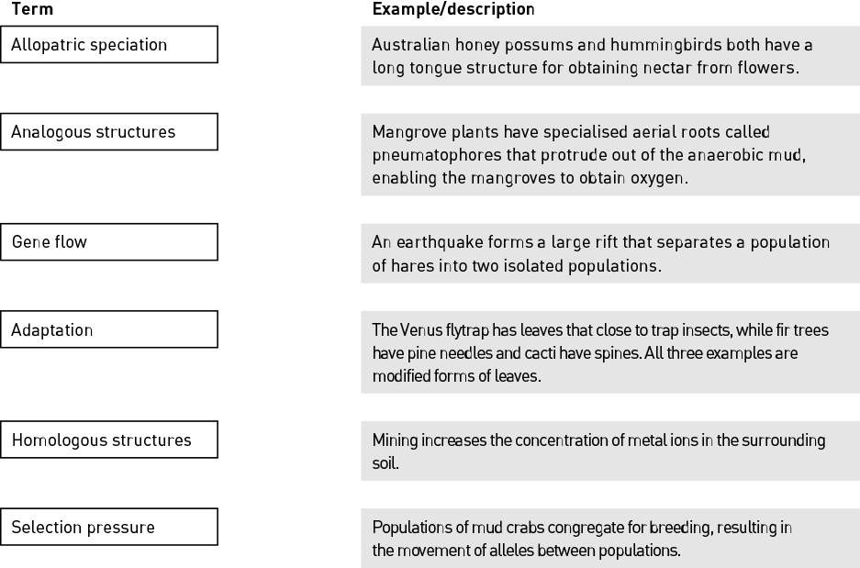

2 Explain why the wings of bats and birds are described as analogous structures yet their forelimbs are homologous structures.

|  |
| --- |
|  |
|  |
|  |
|  |
|  |
|  |

3 Fill in the blanks to complete the paragraph below.

Within any population there is between individuals. A population is sometimes split into two and become from each other. This means there is no   
 . Each population is exposed to different . This changes the allelic frequency within each population and they eventually become   
 isolated and can no longer interbreed. Two different species are formed that have   
 during the process of allopatric .

4 Describe the difference between natural selection and divergent evolution.

|  |
| --- |
|  |
|  |
|  |
|  |
|  |
|  |
|  |

Extend your understanding

5 In the space below, draw an annotated diagram outlining how different selection pressures result in divergence.

|  |
| --- |
|  |

Student worksheet

2.4 Fossils provide evidence of evolution

Pages 48–51

Fossil evidence

1 Complete the following table by writing the correct terms and definitions in the spaces provided.

|  |  |
| --- | --- |
| Term | Definition |
| Fossil |  |
|  | The process of an organism becoming a fossil |
| Transitional fossil |  |
|  | A method that uses the amount of radioactivity remaining in the rock surrounding the fossil to determine its age |
|  | An existing species of ancient lineage that has remained unchanged in form for a very long time |
| Half-life |  |

2 Use the image of a fossil to answer the following questions.

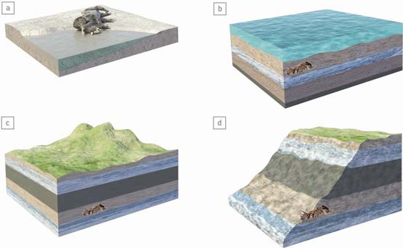

a Is this a relatively young fossil or a relatively old fossil?

|  |
| --- |
|  |

b Name ONE process that will eventually expose this fossil.

|  |
| --- |
|  |

c Outline how relative dating could be used to determine the age of this fossil.

|  |
| --- |
|  |
|  |
|  |
|  |

3 Why is absolute dating a more accurate dating method than relative dating?

|  |
| --- |
|  |
|  |
|  |
|  |
|  |

Extend your understanding

The Wollemi pine or ‘dinosaur tree’ was discovered in 1994 in rugged, undisturbed forests of the Wollemi National Park, New South Wales. This species is virtually identical to fossil remains found throughout Australia, New Zealand and Antarctica. The Wollemi pine is estimated to be 90–200 million years old.

4 Because it has remained relatively unchanged for a long period of time, what is the Wollemi pine an example of?

|  |
| --- |
|  |

5 Suggest what the environment would have been like when this fossil existed over 90 million years ago. Justify your answer.

|  |
| --- |
|  |
|  |
|  |
|  |

6 There are fewer than 100 individual Wollemi pine trees left in the wild and they are all are genetically identical. Explain how a lack of genetic variation could ultimately lead to extinction unless the environment remains the same.

|  |
| --- |
|  |
|  |
|  |
|  |

Student worksheet

2.5 Multiple forms of evidence support evolution

Pages 52–55

Evidence for evolution

1 In your own words, define continental drift.

|  |
| --- |
|  |
|  |

2 Identify TWO pieces of evidence that support continental drift.

|  |
| --- |
|  |
|  |
|  |
|  |

3 Complete the following table by describing how each image provides evidence for evolution, and give two examples for each.

|  |  |  |
| --- | --- | --- |
| Image | Evidence | Examples |
|  |  |  |
|  |  |  |
|  |  |  |

4 List THREE vestigial structures that are found in the human body.

|  |
| --- |
|  |
|  |
|  |

5 A student wrote the following statements regarding evidence for evolution. Determine whether each statement is true or false. For each false statement, write the correct description underneath it.

|  |  |
| --- | --- |
| Description | True or False? |
| At one point in time, all the land masses were joined as the supercontinent Gondwana. |  |
| Australia and Antarctica were once joined about 65 million years ago. |  |
| The early embryo of a horse first develops five finger-like digits that are then modified into a hoof in later stages of embryo development. |  |
| The forelimbs of different birds, whales and bats are examples of vestigial structures. |  |

Extend your understanding

6 Goosebumps are designed to raise the hairs on our skin to trap a warm layer of air and therefore reduce heat loss. Suggest why goosebumps are considered a vestigial feature in humans.

|  |
| --- |
|  |
|  |
|  |
|  |

7 Suggest why vestigial organs are still present within an organism if they no longer serve a purpose.

|  |
| --- |
|  |
|  |
|  |
|  |

Student worksheet

2.6 DNA and proteins provide chemical evidence for evolution

Pages 56–57

Chemical evidence for evolution

1 What is the process that occurs during protein synthesis whereby amino acids are joined together to form proteins?

|  |
| --- |
|  |

2 Describe the difference between an amino acid, a polypeptide chain and a protein.

|  |
| --- |
|  |
|  |
|  |
|  |

3 Haemoglobin is a protein made up of four polypeptides that transports oxygen around the body. One of these polypeptides has 147 amino acids in vertebrates. The table shows the number of different amino acids in the haemoglobin polypeptide in different vertebrates when compared with human haemoglobin.

|  |  |
| --- | --- |
| Vertebrate | Number of different amino acids |
| Gorilla | 1 |
| Chicken | 45 |
| Frog | 67 |
| Mouse | 27 |
| Dog | 32 |

a Order the vertebrates based on how closely related they are to humans based on the amino acid sequence of one haemoglobin polypeptide.

|  |
| --- |
|  |
|  |

b Does this support the hypothesis that humans are more closely related to primates than other vertebrates? Justify your answer.

|  |
| --- |
|  |
|  |
|  |

c What might have caused the change in the single amino acid change between gorillas and humans?

|  |
| --- |
|  |

d Although there is only one amino acid difference between gorillas and humans, there may be many more differences in the DNA sequence of the gorilla haemoglobin gene. Suggest a reason for this.

|  |
| --- |
|  |
|  |
|  |
|  |
|  |
|  |

Extend your understanding

4 In the space below, sketch a basic phylogenetic tree regarding haemoglobin based on the information provided in the table in question 3.

|  |
| --- |
|  |

5 What conclusions can you make about species that have significant differences in their DNA sequences?

|  |
| --- |
|  |
|  |
|  |
|  |
|  |

Student worksheet

2.7 Humans artificially select traits

Pages 58–59

Artificial selection

1 Write definitions for the following terms.

|  |  |
| --- | --- |
| Term | Definition |
| Binary fission |  |
| Artificial selection |  |
| Subspecies |  |
| Domesticated |  |

2 Fill in the blanks.

Bacterial species can pass on antibiotic resistance to another bacterial species by a process known as   
 . This is where the antibiotic resistance is transferred from one bacterium to another. Because the bacterial cell divides by , every bacterium produced also has the gene and the species rapidly.

3 For each organism below, identify the desirable trait that has been selected for and suggest a reason the trait was selected.

|  |  |  |
| --- | --- | --- |
| Organism | Desired trait | Reason for trait being selected |
|  |  |  |
|  |  |  |

4 Wild fowls lay up to 30 eggs per year compared with barn chickens that can lay up to 300 eggs per year. Barn chickens have been selectively bred from wild fowls.

a Suggest ONE advantage and ONE disadvantage that could come from the selective breeding of chickens.

|  |
| --- |
|  |
|  |

b Outline the process a breeder could have used to selectively breed chickens that lay many eggs.

|  |
| --- |
|  |
|  |
|  |
|  |

Extend your understanding

5 Using the following word list (plus any of your own words), create a Venn diagram in the space below to compare and contrast the processes of natural selection, genetic manipulation and artificial selection.

Word list: Human interference, recombinant DNA, mutation, gene transfer, evolution, Galapagos finches, antibiotic resistance, selection pressure, insulin production, transgenic, MRSA bacteria

|  |
| --- |
|  |

Student worksheet

2.8 Natural selection affects the frequency of alleles

Pages 60–61

Changes in alleles frequencies

1 What is the cause of sickle cell anaemia?

|  |
| --- |
|  |
|  |

2 What is the pattern of inheritance of the disease sickle cell anaemia?

|  |
| --- |
|  |

3 Fill in the blanks.

A single base change to the nucleotide triplet sequence from CTC to within the haemoglobin gene results in the amino acid glutamic acid (GLU) being substituted with   
 . This results in a protein where the haemoglobin molecules are shaped like and together.

4 Label and match the normal and mutated haemoglobin proteins to the normal and sickle cell red blood cells they produce.

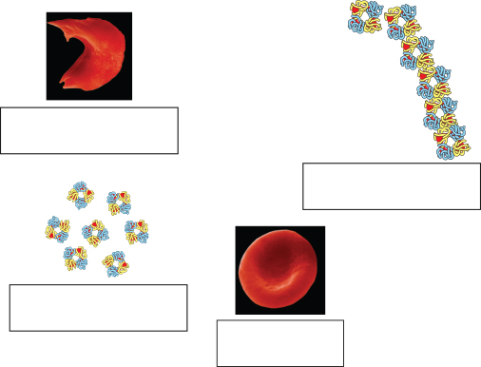

6 The following diagram shows the regions around the world with increased frequency of the sickle cell allele.

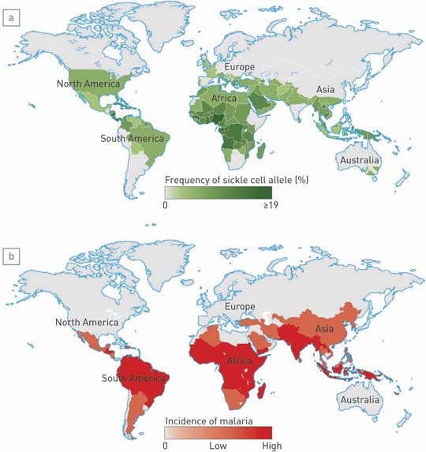

a Identify the selection pressure that results in an increase in the sickle cell allele in these regions.

|  |
| --- |
|  |

b What benefit does this disadvantageous mutation have to individuals in these regions?

|  |
| --- |
|  |
|  |

c Explain why heterozygous individuals have an increased chance of survival compared with homozygous dominant and homozygous recessive individuals in these regions.

|  |
| --- |
|  |
|  |
|  |
|  |
|  |
|  |

Extend your understanding

7 Outline how the process of natural selection has led to an increase in the sickle cell allele over time in malaria-prone regions.

|  |
| --- |
|  |
|  |
|  |
|  |
|  |
|  |
|  |
|  |
|  |
|  |
|  |
|  |
|  |
|  |